Movie Recommendation System

Project Title
Movie Recommendation System using FastAPI and Streamlit
Objective
The objective of this project is to recommend movies to users based on their input. The system provides a list of suggested movies through a simple web interface.
Technologies Used
- Python
- FastAPI
- Streamlit
- Pandas
- Uvicorn
Project Architecture
Frontend
- Built using Streamlit.
- Accepts movie names from users.
- Sends requests to the backend API.
- Displays recommended movies.
Backend
- Built using FastAPI.
- Reads movie data from a CSV file.
- Generates movie recommendations.
- Returns recommendations as JSON responses.

Dataset
A CSV file containing movie names used for generating recommendations.
Folder Structure
Movie Recommendation System/
├── backend/
│ ├── dataset/
│ │ └── movies.csv
│ ├── main.py
│ └── requirements.txt
├── frontend/
│ ├── app.py
│ └── requirements.txt
Working Procedure
- User enters a movie name.
- Streamlit sends the movie name to FastAPI.
- FastAPI reads the movie dataset.
- Five movie recommendations are generated.
- Recommendations are sent back to Streamlit.
- Results are displayed on the screen.
Features
- User-friendly interface.
- Fast recommendation generation.
- API-based architecture.
- Easy to extend with machine learning models.
- Lightweight and beginner-friendly project.
Sample Input
Harry Potter
Sample Output
Recommended Movies:
- The Chronicles of Narnia
- Avatar
- Inception
- Interstellar
- The Dark Knight

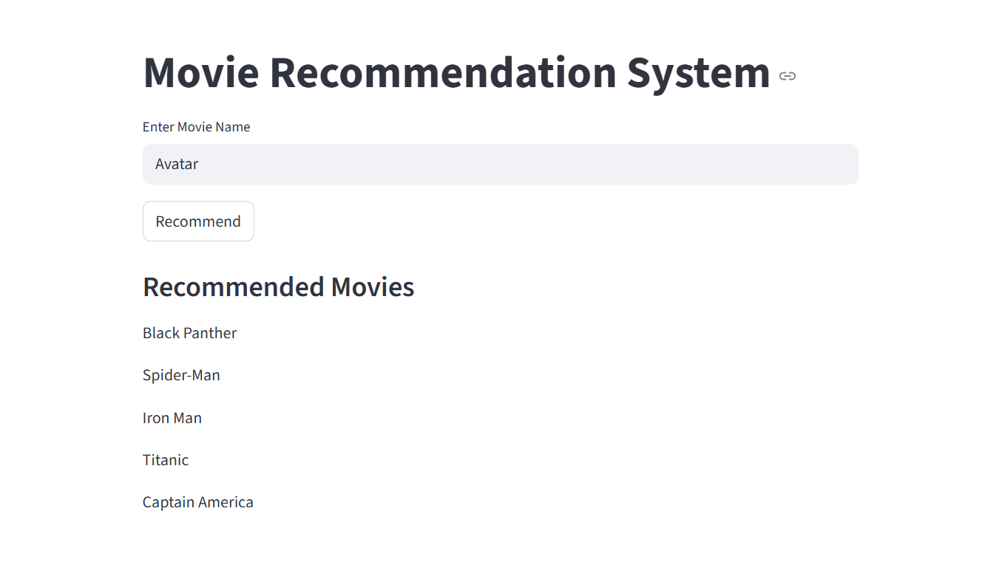

Future Enhancements
- Content-based recommendation system.
- Collaborative filtering.
- Genre-based recommendations.
- Movie posters and ratings integration.
- Database connectivity.
- User login and personalized recommendations.
Conclusion
The Movie Recommendation System demonstrates the integration of FastAPI and Streamlit to build a simple recommendation application. It provides movie suggestions through an interactive web interface and serves as a foundation for advanced recommendation systems.

